____________________________________________________

OSPF Multi-Area and LSA Background Information

____________________________________________________

*Author*:

Gabriel Rosas



Background Information

Routing

Routing is a significant process in networking as it allows hosts on different IP networks to connect to each other. *Open Shortest Path First* (OSPF) is a routing protocol simplifying the process of creating routes by using algorithms to figure out the directions automatically. OSPF excels in interior networks, which are smaller in scale, but would crash in large networks with hundreds of routes. In networking, routes are ultimately just *directions* for packets.

There are two options when dealing with traffic on a network; you can configure *static routes*, or you can set up a *routing protocol*. I like to think of static routes as absolute directions drawn onto a map, set in stone and unchangeable. The map can’t be altered unless it is manually redrawn. If you were to follow the map, you might find some of the routes to be outdated.

It would be nice if routes were adaptable, if they could update based on the fastest paths available. This is the difference between *static routing* and *routing protocols*. Routing protocols update their routing directions automatically based on information sent from neighbors. This is the magic of routing protocols: automatic updates and directions – like google maps – for packets. Routes are stored in a database on the router, known as a *routing table*.

Routing tables

Like a signpost at a fork in the road, routers contain directions for different destinations. These directions are stored in RAM memory on the router, which means that they are temporary; RAM memory can be accessed much faster than hard drives or SSDs but is not saved after the device shuts down. Let’s look at an example of a packet arriving at a router.

A packet arrives at a router. This router has three interfaces: north, south, and east. The packet arrived on the east interface, so it either must turn north or south, assuming one of these paths lead to the destination. Luckily, there are directions in the router: *10.0.0.0/24* out interface *north*; *172.16.0.0/24* out interface *south*. The packet has a destination address of *10.0.0.3*, which matches up with the *north* interface. The router sends the packet out the north interface. Routes are either generated statically, by the admin, or automatically by routing protocols such as OSPF, BGP, etc.

Here is an example of a routing table:

|  |
| --- |
| Gateway of last resort is not set  10.0.0.0/8 is variably subnetted, 11 subnets, 2 masks  O IA 10.10.10.0/30 [110/128] via 10.10.10.5, 01:03:27, Serial0/1/1  C 10.10.10.4/30 is directly connected, Serial0/1/1  L 10.10.10.6/32 is directly connected, Serial0/1/1  C 10.10.10.8/30 is directly connected, Serial0/1/0  L 10.10.10.9/32 is directly connected, Serial0/1/0  O IA 10.10.10.12/30 [110/128] via 10.10.10.10, 01:03:27, Serial0/1/0  C 10.10.10.16/30 is directly connected, Serial0/2/0  L 10.10.10.17/32 is directly connected, Serial0/2/0  O IA 10.10.10.20/30 [110/128] via 10.10.10.18, 01:03:27, Serial0/2/0  O IA 10.10.10.24/30 [110/192] via 10.10.10.18, 01:03:27, Serial0/2/0  O E2 10.10.10.28/30 [110/100] via 10.10.10.18, 01:03:27, Serial0/2/0 |

Ignoring the letters on the left (the origin of the route), we can see a range of addresses and the corresponding interface leading towards them. For example, *10.10.10.0/30* addresses direct out the *Serial0/1/1* interface. “Via *ip*”, is also commonly seen as a direction, indicating that a packet should be sent to the specified neighboring router. Sometimes there is a combination of directions: both *interface* and *neighboring ips*.

OSPF

Since we’ve defined routing and routing tables, I can go into more detail on how OSPF functions. Each router is like a junction for packets; packets usually have multiple roads they can turn down to reach further junctions, ultimately ending at their destination. Every router running OSPF will communicate with neighbor OSPF routers to relay statuses and updates about new routes and preferred paths. By sharing information to neighbor OSPF routers, information can spread through an OSPF network regardless of hop counts between routers. The packets OSPF broadcasts to relay information are known as *Link-State Advertisements* (LSAs).

* Type 1: *Router LSA*
  + Generated by every router.
  + Contains information about the router and lists links to other routers or networks *in the same area*.
  + Appears in a local area only and will be dropped by *Area Border Routers* (ABR).
  + The link state ID is the router ID of the router who originated the LSA packet.
* Type 2: *Network LSA*
  + Only generated by the Designated Router (DR) in a broadcast network type.  
    *For example, if four routers are connected to the same switch, this system becomes a broadcast network. In a broadcast network, one router will be designated to handle most of the updates between the other routers, conserving bandwidth.*
  + Contains *the subnet of the broadcast segment*.
  + Appears in a local area only and will be dropped by *Area Border Routers*.
  + The link state ID is the IP address of the DR.
* Type 3: *Summary LSA*
  + Generated by an *Area Border Router*.
  + Informs *external areas* about networks in a *local area*.
  + Forwarded by *Area Border Routers*.
  + The link state ID is the network address of the advertising ABR.
* Type 4: *ASBR Summary LSA*
  + Generated by an *Area Border Router* in an area containing an *Autonomous System Border Router* (ASBR).  
    *ASBRs are routers that bridge different routing protocols.*
  + Advertisesroutes to the *Autonomous System Border Router* in the area.
  + Flooded in all areas except the area containing the ASBR.
  + The link state is the ASBR’s router ID.
* Type 5: *ASBR External LSA*
  + Generated by an *Autonomous System Border Router.*
  + Advertises external routes connected to the ASBR.
  + Flooded through all areas.
  + The link state ID is the external network number.
* Type 6: *Group Membership LSA* 
  + Designed for *Multicast OSPF* (MOSPF) but is no longer supported by Cisco.
  + MOSPF is deprecated as of OSPFv3 and is not widely used.
* Type 7: *Not so Stubby Area LSA*
  + Generated for external routes that enter a *Not So Stubby Area* (NSSA).  
    *NSSAs block externally distributed routes to save bandwidth.*
  + LSA type 5 packets are blocked or translated to LSA type 7 packets when entering an NSSA. Once the packets exit an *Area Border Router* in the NSSA, they are retranslated back to type 5 LSA packets.

Cost and OSPFv3

OSPF configured routers rely on *cost* to commute the shortest path through a network. While you can set the cost manually, OSPF will automatically determine the cost value per interface based on a *reference bandwidth* – usually the bandwidth of the fastest interface in your network – and *interface bandwidth***,** the bandwidth of the interface being assessed.

There are two OSPF protocols that can be configured on a router: OSPFv2 and OSPFv3, the main difference being *OSPFv2* routes *IPv4* and *OSPFv3* routes *IPv6*. OSPFv3 has nine *Link-State Advertisements*. LSAs are used to communicate different states and information of an OSPF router, such as a neighbor’s local topology, to build the *routing table*. Although there are other routing protocols such as EIGRP, OSPF is massively adopted in large enterprise networks because of its many benefits: route redundancy, the ability to run on most routers, classless routing, and loop-free topologies.

Multi-area OSPF

OSPF routers communicate to each other using LSA packets, but this communication comes at a cost: bandwidth. When OSPF runs across a large network, LSA packets consume more bandwidth, as there are more routers that send updates. If the network has low-bandwidth interfaces, LSA traffic could hinder the performance. But what if we could limit the amount of LSA traffic on a network?

*Multi-area OSPF* is the process of dividing routers into multiple groups, known as *areas*, to reduce the size of LSA packets that need to be sent. Routes need to be specific and abundant for each network advertised within a local area. However, routers in a local area only need a broad definition of networks in external areas. Therefore, LSA packets across areas transmit summarizations by compressing multiple lines of routes into a single subnet. Let’s compare a single-area OSPF network to a multi-area OSPF network.

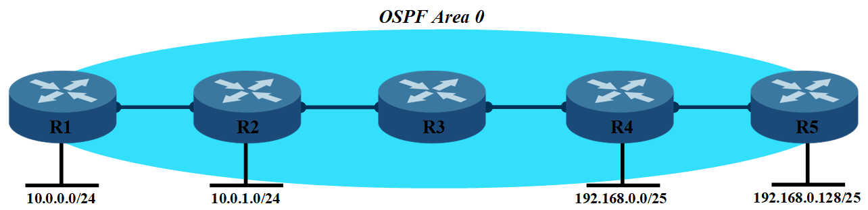

In this topology, each router needs a specific route for every network in the area. LSA packets would be abundant in this area for each network OSPF is advertising. There would be no summarizations. A routing table on R2 may look something like the following:

* *10.0.0.0/24 out interface GigabitEthernet0*
* *192.168.0.0/25 out interface GigabitEthernet1*
* *192.168.0.128/25 out interface GigabitEthernet1*

Now let’s divide this network into two areas.

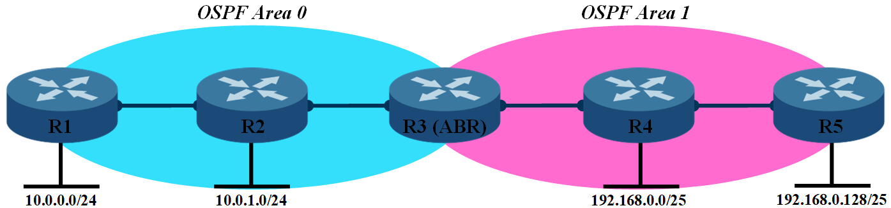

Now that there are multiple areas, we can summarize networks for each area. Instead of routers four and five having routes to the *10.0.0.0/24* and *10.0.1.0/24* networks, they can share a singular, summarized route, *10.0.0.0/23*, that points towards the ASBR. When a packet enters the destination area, more precise routes will direct it to the destined network. An LSA packet to *area 0* from *area 1* might be distributing the following network, *192.168.0.0/24*, only consisting of one prefix. Compared to LSAs containing all the specific routes, *route summarization* helps reduce LSA packet sizes. Now, the routing table on R2 may look something like the following:

* *10.0.0.0/24 out interface GigabitEthernet0*
* *192.168.0.0/24 out interface GigabitEthernet1*

Specialized Areas

While multi-area OSPF may appear to be the most optimal bandwidth conservation option, we can push OSPF further. *Specialized Areas* are additional OSPF configurations that *block* certain LSA types to limit even more LSA traffic. However, specialized areas are circumstantial, requiring specific topologies to properly function. There are three specialized area types that I will cover in this paper: *Stubby*, *Totally Stubby*, and *Not So Stubby* areas.

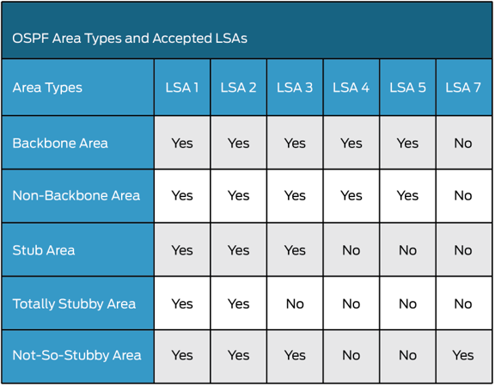

LSA types found per area

Totally Stubby Area

*Totally Stubby Areas* block the most LSA traffic by dropping all LSA packets except types 1 and 2, in doing so conserving the most bandwidth of all the specialized areas. A Totally Stubby Area must contain only one *Area Border Router*, so all external traffic can flood out of a default gateway. There are no external routes because there is only one destination for a packet: out the ABR. Totally Stubby Areas cannot contain an ASBR; this is important because ASBRs generate LSA type 4 and 5 traffic which are not permitted in the area. While Totally Stubby Areas conserve the most bandwidth, they are also very situational.

Stub/Stubby Area

*Stubby Areas* are much like Totally Stubby Areas but can be connected to *more than one Area Border Router*. This circumstance does come at a cost: LSA type 3 (summary) traffic is permitted throughout the area. By containing more than one ABR, the network is

Stubby areas block external routes like totally stubby areas- something that all three specialized areas have in common. While setting up default routes may be more complicated in this area due to multiple exit points, typically the best place to set default routes up is the ABR leading out towards the internet. Other ABRs in a stub area rely on route summary.

Stub areas are used since they retain smaller databases by excluding external routes, but still flood more LSA traffic than totally stubby areas.

Not so Stubby Area

Not so Stubby areas were designed for areas **containing an ASBR**. Like stub and totally stubby areas, NSSAs block external routes. When you think about it, the point of ASBRs are to advertise external routes, so how can an area containing an ASBR block external routes? NSSAs use type 7 LSA packets to camouflage the external route packets that ASBRs broadcast. Routers in the NSSA ignore these packets while they flood out of the NSSA. Once out of the NSSA, **type 7 LSAs are translated to type 5 LSAs** which contain the external routes of the ASBR.

By being connected to an ASBR and potential ABRs, an NSSA floods four LSA types throughout the area: types 1, 2, 3 and 7. NSSAs are a good choice to configure when dealing with an ASBR.